**HEATING CYCLE 1**

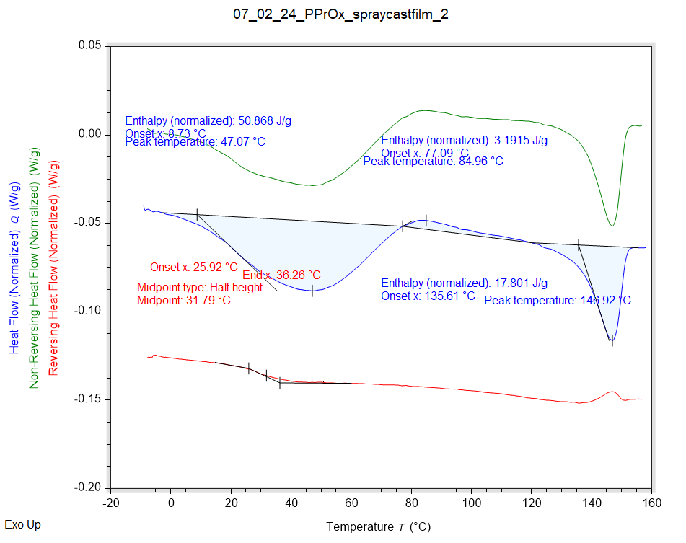

|  |  |  |  |
| --- | --- | --- | --- |
| Solvent HC1 | Peak Onset | Peak Location | Enthalpy |
|  | 8.729 °C | 47.072 °C | 50.868 J/g |

|  |  |  |  |
| --- | --- | --- | --- |
| Recrystallisation HC1 | Peak Onset | Peak Location | Enthalpy |
|  | 77.093 °C | 84.959 °C | 3.1915 J/g |

|  |  |  |  |
| --- | --- | --- | --- |
| Melting HC1 | Peak Onset | Peak Location | Enthalpy |
|  | 135.614 °C | 146.918 °C | 17.801 J/g |

|  |  |  |  |
| --- | --- | --- | --- |
| Tg HC1 | Onset | Midpoint | End |
|  | 25.922 °C | 31.794 °C | 36.256 °C |

**HEATING CYCLE 2**

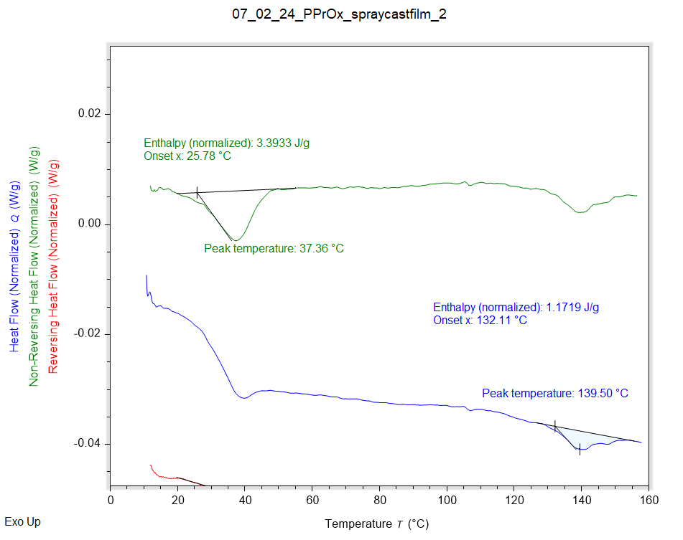

|  |  |  |  |
| --- | --- | --- | --- |
| Solvent HC1 | Peak Onset | Peak Location | Enthalpy |
|  | 25.784 °C | 37.364 °C | 3.3933 J/g |

|  |  |  |  |
| --- | --- | --- | --- |
| Melting HC1 | Peak Onset | Peak Location | Enthalpy |
|  | 131.729 °C | 139.427 °C | 1.3145 J/g |

|  |  |  |  |
| --- | --- | --- | --- |
| Tg HC1 | Onset | Midpoint | End |
|  | 34.183 °C | 40.211 °C | 46.191 °C |

**HEATING CYCLE 3**

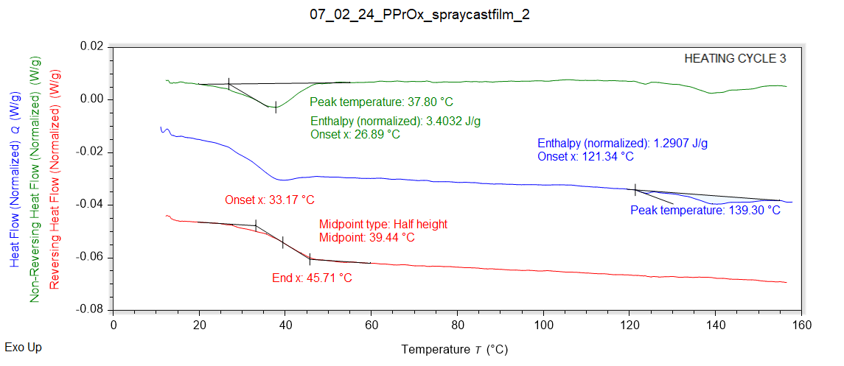

|  |  |  |  |
| --- | --- | --- | --- |
| Solvent HC1 | Peak Onset | Peak Location | Enthalpy |
|  | 26.893 °C | 37.805 °C | 3.4032 J/g |

|  |  |  |  |
| --- | --- | --- | --- |
| Melting HC1 | Peak Onset | Peak Location | Enthalpy |
|  | 121.341 °C | 139.300 °C | 1.2907 J/g |

|  |  |  |  |
| --- | --- | --- | --- |
| Tg HC1 | Onset | Midpoint | End |
|  | 33.166 °C | 39.442 °C | 45.714 °C |